HCI Robot Assignment Design Document

by Stephen Davison

Design:

I created this application by creating classes to follow this diagram:

RoboApp

RoboApp2
RoboCanvas
Body

Arm

Hand

Finger
Finger

The creation of this application was facilitated by the way in which all the classes are similar, so classes could be copied and slightly altered. It would probably have been easier to create an abstract class called say, robotPiece that would give all the functionality of the classes and call methods in much smaller classes for every piece than was actually implemented, but I feel the structure I chose gave more indication of the relationship between the actual objects I was manipulating.

State Diagram:

Here is a state diagram of my application. It is fairly simple, with a feel of you get what you want and then your back in the waiting stage.
There is a restriction feature that stops parts of the robot moving in certain directions, it is set at +/- 250 units for the robot body, +/- 330 degrees for the arm and the hand, and +/- 5 units for the fingers. I thought this would model a robot in real life, that might not have the ability to rotate its arm all the way round.

Robot moving
Fingers Moving

Robot moving Arm
Robot Moving Hand

Robot Doing Nothing

Speed Changing

Interface diagram

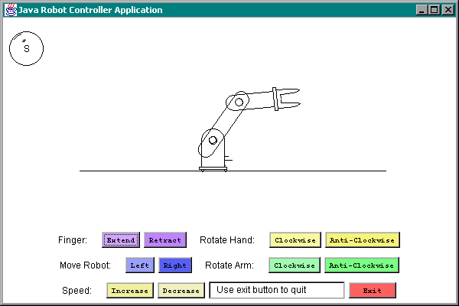

I implemented it this way because of many reasons. One is that I felt it made sense to cluster the functionality of the different parts of the robot in different parts of the button bar. The next is that I felt the order in which I would most need buttons if I was a robot would be in the order that filters down from the top left corner, since there is a speedometer in the top left hand corner that your attention switches from. The order is:
Move fingers; Move hand; Move arm, Move body; Increase speed; Quit Application.
The quit button is designed to be far enough away from the usual buttons to avoid being accidentally pressed, and is bright red as in danger or a STOP road sign.
The speedometer is a visualisation of what happens when you press the Speed controls, as every other object on the screen has some effect, and the speed didn’t, I thought it would be useful.

The nav text bar is an idea that is taken from an example I saw. I thought it would be really useful if the user had a better idea of what was going on, and had a brief aid to memory that would say what the user had recently done. For example, if the user had increased the speed and come back later, it might be a good idea to remind the user that, by the way, the speeds on maximum.
The speedy lines are a bonus that have no function other than to give a brief reminder of the speed of the robot, and to give a brief reminder to the fact that something just moved.
The pretty coloured buttons are the to relax the user and make the user feel comfortable. The text is meant to be unambiguous, but the words are a little too complex for my personal choice.

Conclusions

What was good about this project was that it was fun and you get results when you code, which makes it easier. I was a little unsure of my method to rotate shapes, which is to distort where the screen draws the shapes, and I was a little unsure about using java 2 for this project. I wish I had enough time to experiment with colours and other special effects, such as gradient colour. My program could have been updated to have alterable shapes for each robot piece, but for now, that information is locked in the various classes for that part of the robot.
What is bad about my program is the way I have knitted the classes together in a way that is perhaps a little too close. I think this was a big error on my part.
I spent around 28 hours in total on this project, with about 2 hours of testing, including testing with other people, about 6 hours of using suns documentation on their website, and around 17 hours of mixed coding and testing, in the midst. I have also done around 3 hours of design and redesign of the method I used to rotate and translate, and additional features I have stuck in.

